Research Goals:

Find cutoffs criteria for healthy individuals and those with respiratory illness.

Think of reasonable amounts of control for user to customize IAQ without setting unachievable goals

Find energy impacts of windows, fans, more time outdoors, removal of carpet, air purifiers, mold abatement, low VOC paints and furnishings, and other IAQ modifying strategies

Find 3-4 effective recommendations

<http://www.sciencedirect.com/science/article/pii/S1352231002001577> this paper and its linked recommended papers. (more about model accuracy)

<https://www.kane.co.uk/knowledge-centre/what-are-safe-levels-of-co-and-co2-in-rooms> WHO limits on CO2 (ASHRAE and the WHO have very well documented literature on the health effects of various pollutant concentrations. EPA on the other hand has no such guidelines and only provides recommendations

<https://www.engineeringtoolbox.com/co2-comfort-level-d_1024.html> link between ventilation rate and CO2 levels

<https://scholar.google.nl/citations?user=xJjvdIUAAAAJ&hl=nl> Pawel Wargocki (see papers in Oct 30 folder). Determined linear relationship between ventilation rate between 3 and 30 cfm and acute health effects, . Analyzed 10 studies and found 6-9% difference in productivity which is very significant for an IEQ study. H index = 33

<https://scholar.google.nl/citations?user=VmIfI48AAAAJ&hl=nl> david wyon, colleague at Denmark TU H-index = 43

In one Wyon Wargocki study, they saw a 1.7% increase for every 2 fold increase in ventilation rate from 3 to 30 cfm. Only 3 data points.

**Questions for Nazaroff:**

What kind of effect sizes should we expect for various strategies? Which ones have you seen evidence for as being highly effective (natural ventilation, fans, carpet, vs increased HVAC operation, etc.)

* Replace carpet
* Open operable windows, does it every have a significant effect if the building is not designed for natural ventilation
* Fans (box and ceiling)
* Increased HVAC operation (as a baseline)
* Reduced VOCs (what kinds of VOC levels do LEED certified buildings usually have since they have fairly strict low VOC requirements.

PM 2.5 is the greatest acute health concern correct? Whereas CO2 is more of a productivity and comfort concern.

<https://www.sparkfun.com/products/14193> This thing says it measures CO2, VOC,, and MOX. How likely is it that those last 2 are very accurate? Could we use the VOC sensor if we’re just trying to flag spaces with exceedingly high levels. Sort of a go/no go check.

PM 2.5 is the greatest acute health concern correct? Whereas CO2 is more of a productivity and comfort concern.

Where can I get real time or same day data on criteria pollutants? That way we don’t need to be continuously monitoring outside to calculate I/O ratios and make decisions about ventilation. I tried the EPA raw data API but I was having trouble getting it to work.

<https://www.epa.gov/outdoor-air-quality-data/download-daily-data> Daily data. Only goes til August so see if real time data is possible

Also, check RH with the sensor and send an alert if it’s too high or low for too long. This one can easily be traced to probabilities of mold or bioeffluent growth.

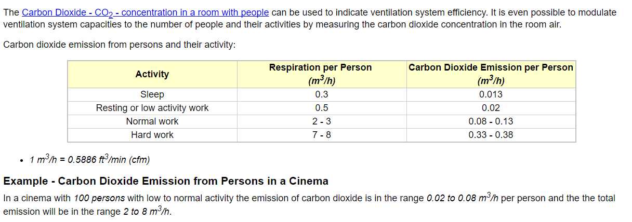

Engineering toolbox, can be used for cfm calculations if people input expected activity type.

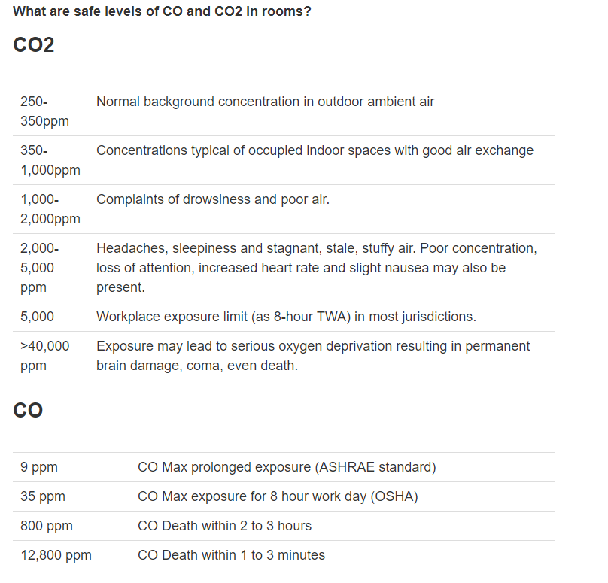

<https://books.google.com/books?hl=en&lr=&id=J5R5AgAAQBAJ&oi=fnd&pg=PA193&dq=effect+of+indoor+co2+on+office+productivity&ots=YOZWW7vBW5&sig=JZ874wPU4iP62M8b8mrXqX2wwiE#v=onepage&q=effect%20of%20indoor%20co2%20on%20office%20productivity&f=false> Ebook on productivity and IAQ

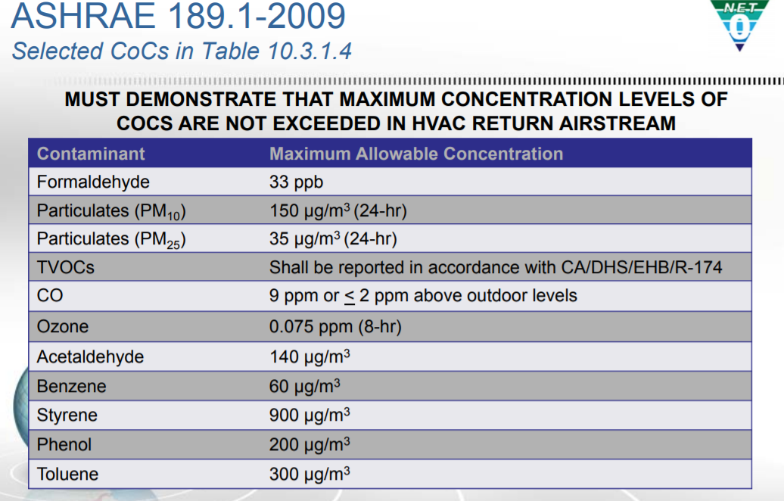

CFM design values range from 15 to 25 cfm per occupant and can be correlated with CO2 concentrations if occupants are the only source of CO2

Get approximate effect sizes for strategies

Eliminate carpeting - >50% reduction in respiratory symptoms

Edge sealing?

low VOC materials?

Increase ventilation rate - 6-9% increase in productivity



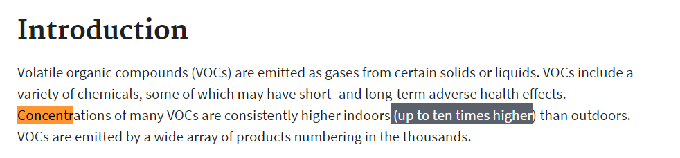

From EPA website on VOC indoor levels

Final Paper sources

<https://www.aeroqual.com/why-monitor-indoor-air-quality> Table of health effects

<http://www.oecd.org/environment/air-pollution-to-cause-6-9-million-premature-deaths-and-cost-1-gdp-by-2060.htm>

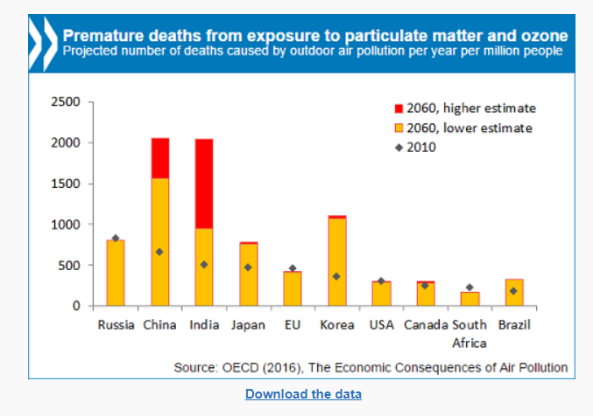

300 deaths per year in US due to air pollution expected

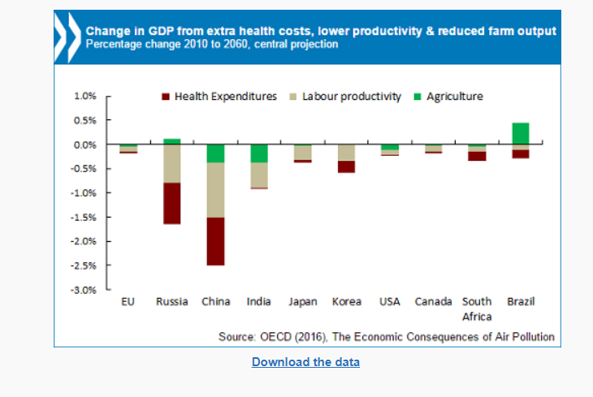- 0.25% of GDP or $46 billion per year, which is more than the entire federal budget for Energy and Environment in 2015.